SIMATS ENGINEERING

ASSESSMENT TOOL 2 : Scenario-Based

COURSE NAME: Cloud Computing and
Big Data Analytics
COURSE CODE: CSA1508

COURSE OUTCOME COVERED
CO2: Analyze virtualization architectures to identify performance and security issues in cloud computing environments. (BL3)

Dave's Taxonomy: Manipulation (Level 2) Question Count: 5
Total Marks: 25

Code of Conduct
I , certify that this submission is my original work and that I have adhered to the guidelines specified for this assessment.
I understand that any violation of academic integrity rules will result in disciplinary action. Signature of the student:

Assessment Tasks Scenario-Based Questions

- A media company wants to migrate its video streaming platform to the cloud. The system must handle millions of concurrent users with minimal buffering. Design a cloud architecture using scalability and caching techniques.
Explain how load balancing and auto-scaling can ensure smooth streaming. Discuss cost optimization strategies for such high-demand workloads.

- A fintech startup is deploying applications using containers across multiple cloud providers. They face challenges in maintaining consistency and managing deployments.
Propose a solution using container orchestration and multi-cloud strategies. Explain how service discovery and scaling can be handled efficiently.
Highlight the benefits and risks of a multi-cloud deployment model.

- An e-learning platform experiences data loss due to accidental deletion in the cloud. The organization needs a robust backup and disaster recovery strategy.
Design a solution using cloud-native backup, replication, and versioning.
Explain how recovery time objective (RTO) and recovery point objective (RPO) are achieved. Provide steps to ensure business continuity during failures.

- A government agency is adopting a hybrid cloud model for sensitive and non-sensitive data. Some applications must remain on-premises due to compliance requirements.
Design a hybrid architecture that ensures secure communication between environments. Explain how identity management and encryption should be implemented.
Discuss challenges in managing hybrid cloud environments.
- A SaaS provider needs to ensure high availability and fault tolerance for its application. The system must continue operating even if one region goes down.
Propose a multi-region deployment strategy in the cloud.
Explain how data replication and failover mechanisms should be configured. Discuss monitoring and alerting strategies for proactive issue detection.

Scenario-Based Rubric

Criteria | Weightage | Level 4 - Exemplary | Level 3 - Proficient | Level 2 - Developing | Level 1 - Beginning
Understanding of Scenario | 20% | Demonstrates complete  understanding of the scenario context | Good understanding with minor gaps | Partial understanding | Fails to understand the scenario
Identification of Risks / Issues | 20% | Identifies all major issues correctly | Identifies most issues | Limited issue identification | Misses major issues
Application of Concepts | 25% | Applies virtualization concepts effectively | Applies  concepts with minor mistakes | Partially correct application | Weak application
Decision Justification | 20% | Decisions are well justified and technically strong | Reasonable justification | Weak justification | No useful justification
Clarity | 15% | Clear and well-organized  response | Generally clear | Somewhat unclear | Poorly presented

Scenario-Based Questions – Solutions

Cloud Architecture for a Large-Scale Video Streaming Platform

Scenario:
A media company wants to migrate its video streaming platform to the cloud. The platform must support millions of concurrent users while maintaining low latency and minimal buffering.

Proposed Cloud Architecture:
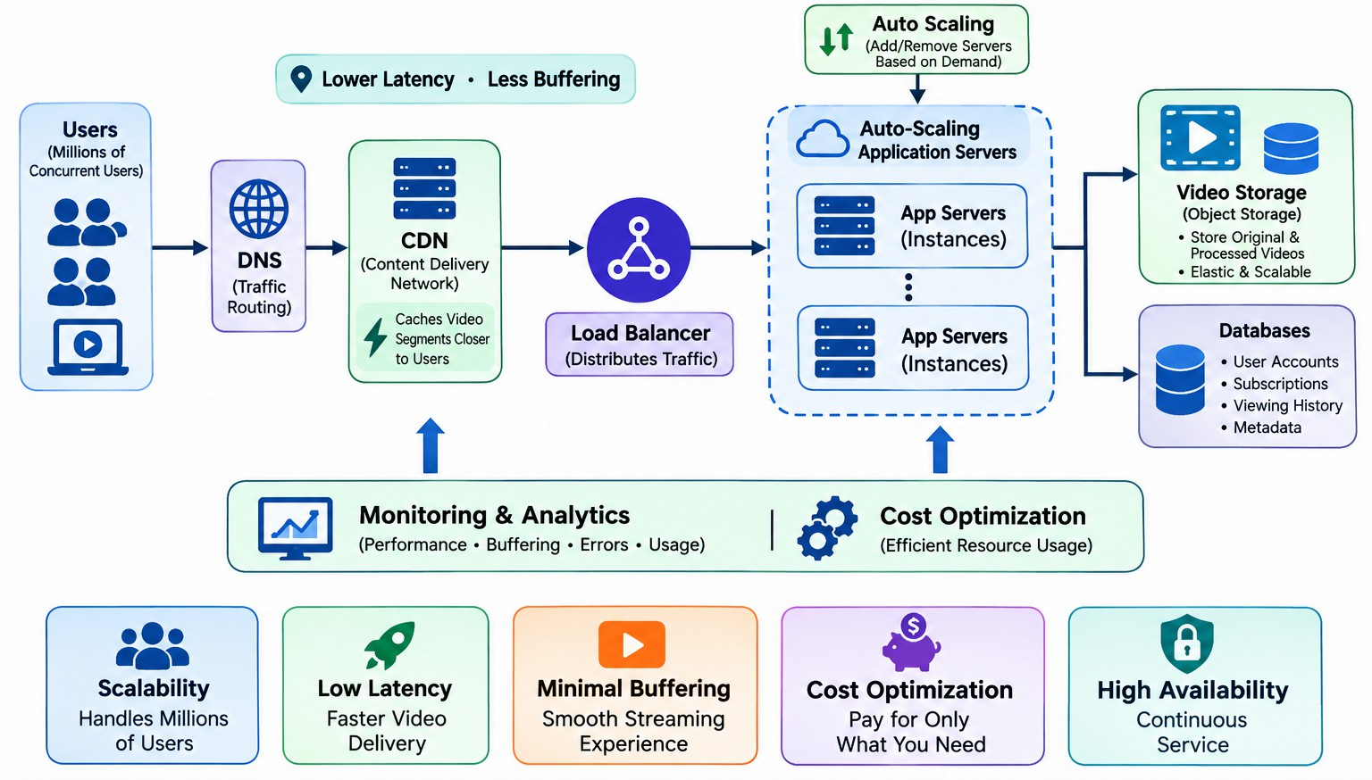

    - Object Storage: Stores original and processed video files.
    - CDN: Caches frequently requested video segments close to users.
    - Load Balancer: Distributes requests across healthy servers.
    - Auto Scaling: Automatically adds or removes application servers according to traffic.
    - Database: Stores user accounts, subscriptions, viewing history, and metadata.
    - Monitoring: Tracks CPU, memory, network traffic, latency, buffering, and errors.

Scalability Techniques
- Horizontal Scaling
  - Add more application servers instead of depending on one powerful server.
  - Allows the platform to support increasing numbers of users.

Auto-Scaling
  - When traffic increases, new instances are automatically created.
  - During low-demand periods, unnecessary instances are removed.

CDN Caching
  - Frequently accessed video segments are cached at geographically distributed edge locations.
  - Users receive content from a nearby location instead of the central origin server.

Elastic Storage
  - Cloud object storage can store huge quantities of videos without requiring physical storage expansion.

Role of Load Balancing
The load balancer distributes incoming requests across multiple application servers.

For example:
1 million requests → Load Balancer → Server 1 + Server 2 + Server 3 + Server 4 If one server fails, the load balancer can stop sending traffic to that unhealthy server. Role of Auto-Scaling
Auto-scaling maintains application capacity according to demand.
High traffic → More instances Low traffic → Fewer instances
This prevents overload and reduces unnecessary infrastructure costs.

Cost Optimization
- Use CDN caching to reduce origin traffic.
- Use object-storage lifecycle policies to move old videos to cheaper storage.

- Use auto-scaling to avoid paying for unused servers.
- Use reserved/committed capacity for predictable workloads.
- Compress and transcode videos efficiently.
- Monitor network and storage costs.
- Use different video quality levels such as 480p, 720p, and 1080p depending on user bandwidth.

Conclusion
A combination of CDN, caching, load balancing, auto-scaling, elastic storage, and monitoring provides a scalable streaming architecture. CDN reduces latency and buffering, while auto-scaling handles sudden traffic increases. Cost can be controlled through caching, lifecycle policies, and
dynamic resource allocation.

Containerized Fintech Applications Across Multiple Clouds

Scenario:
A fintech startup deploys applications using containers across multiple cloud providers. It faces problems with deployment consistency, service management, and scaling.

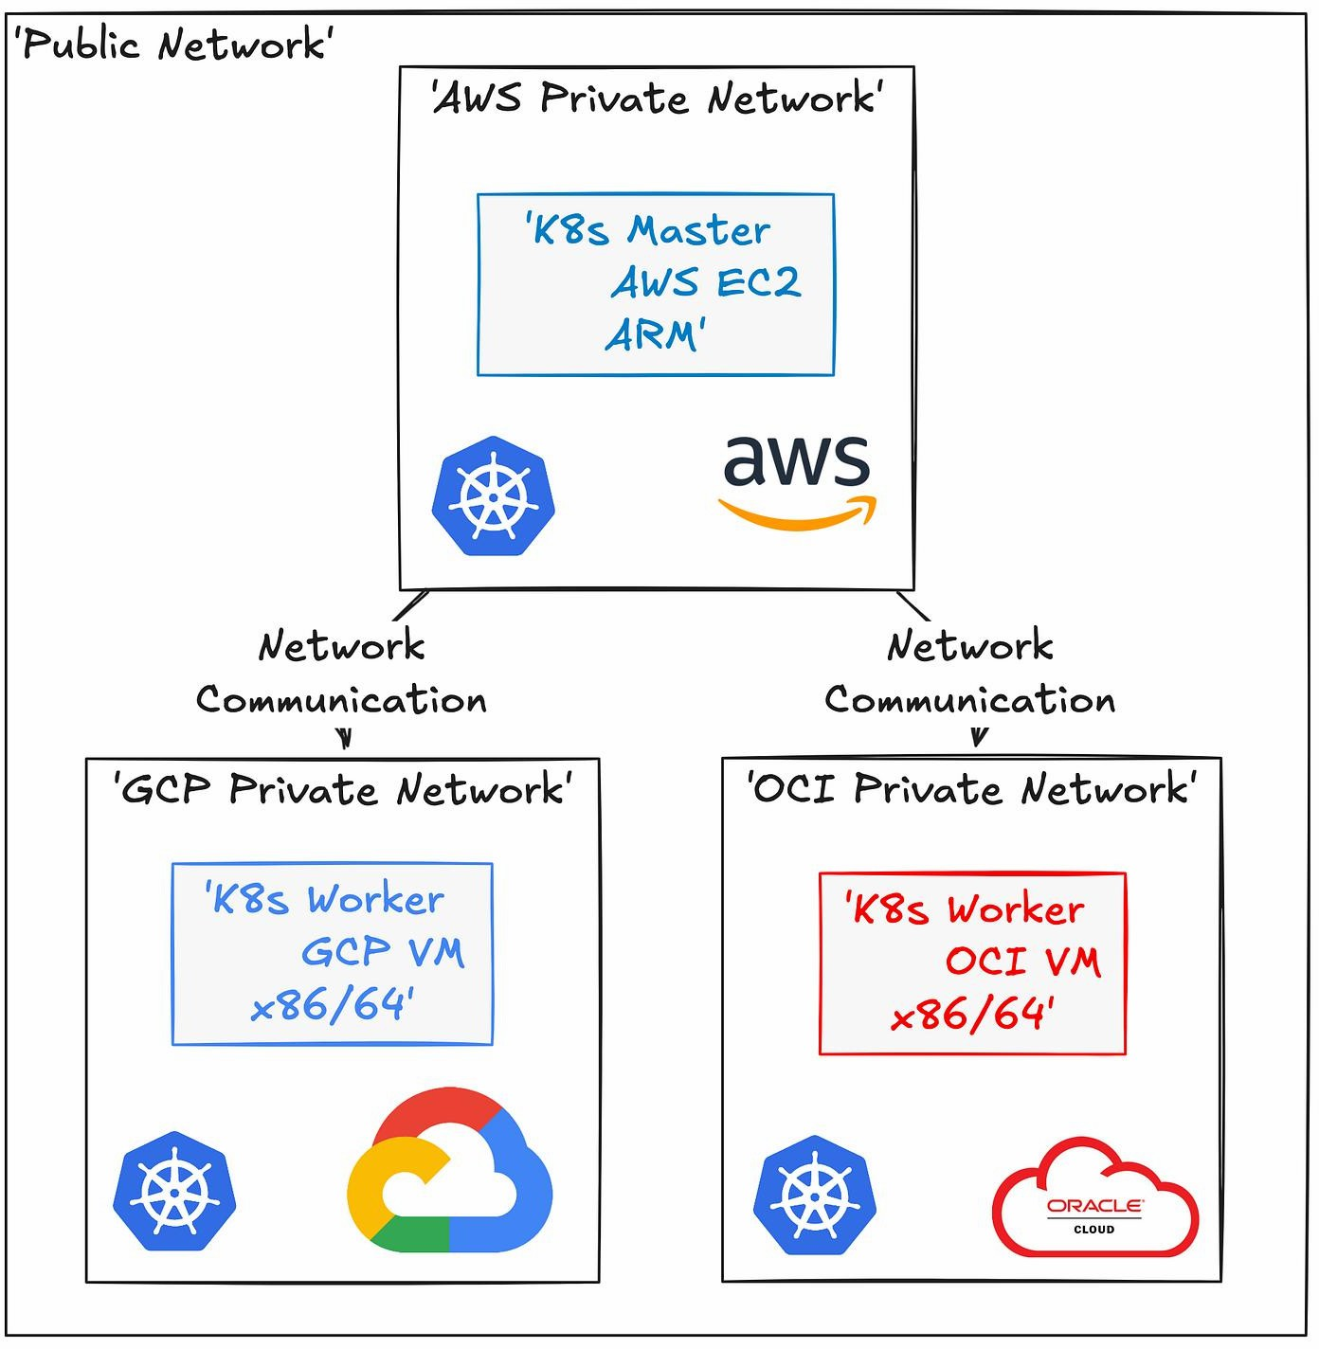
Proposed Architecture:

Container Orchestration:
Kubernetes manages:
    - Container deployment
    - Scheduling
    - Service discovery
    - Scaling
    - Health checks

    - Self-healing
    - Load balancing
Container images should be stored in a container registry so that the same application image can be deployed consistently across providers.

Maintaining Deployment Consistency
The startup should use:
    - Container images
    - Kubernetes manifests
    - Helm charts
    - Infrastructure as Code
    - CI/CD pipelines
    - Automated testing
The same deployment configuration can then be applied to multiple cloud environments.

Service Discovery
Kubernetes provides service discovery so that application components can communicate without depending on fixed IP addresses.

For example:
Payment Service → Authentication Service → User Service → Database
Services can be accessed using stable service names while Kubernetes manages the underlying container IP addresses.

Scaling
Kubernetes can automatically increase or decrease the number of application containers.

Example:
Normal traffic → 3 containers High traffic → 10 containers Low traffic → 2 containers
Horizontal Pod Autoscaling can use metrics such as CPU utilization and application demand.

Multi-Cloud Benefits
- Avoids vendor lock-in
- Improves resilience
- Supports geographical distribution
- Allows workloads to use different cloud capabilities
- Provides flexibility during cloud outages
- Can improve negotiation and cost flexibility Multi-Cloud Risks
  - Increased management complexity
  - Different networking models
  - Different cloud APIs
  - Higher monitoring requirements
  - Data synchronization challenges
  - Increased security complexity
  - Potentially higher operational costs
  - Skill requirements for multiple cloud environments

Conclusion:
A Kubernetes-based multi-cloud architecture provides a consistent container deployment model. Container images, CI/CD, service discovery, autoscaling, and Infrastructure as Code help maintain consistency. However, the organization must carefully manage security, networking,
data synchronization, and operational complexity.

Backup and Disaster Recovery for an E-Learning Platform

Scenario
An e-learning platform loses important data because of accidental deletion. The organization needs a reliable backup and disaster recovery solution.

Proposed Architecture:
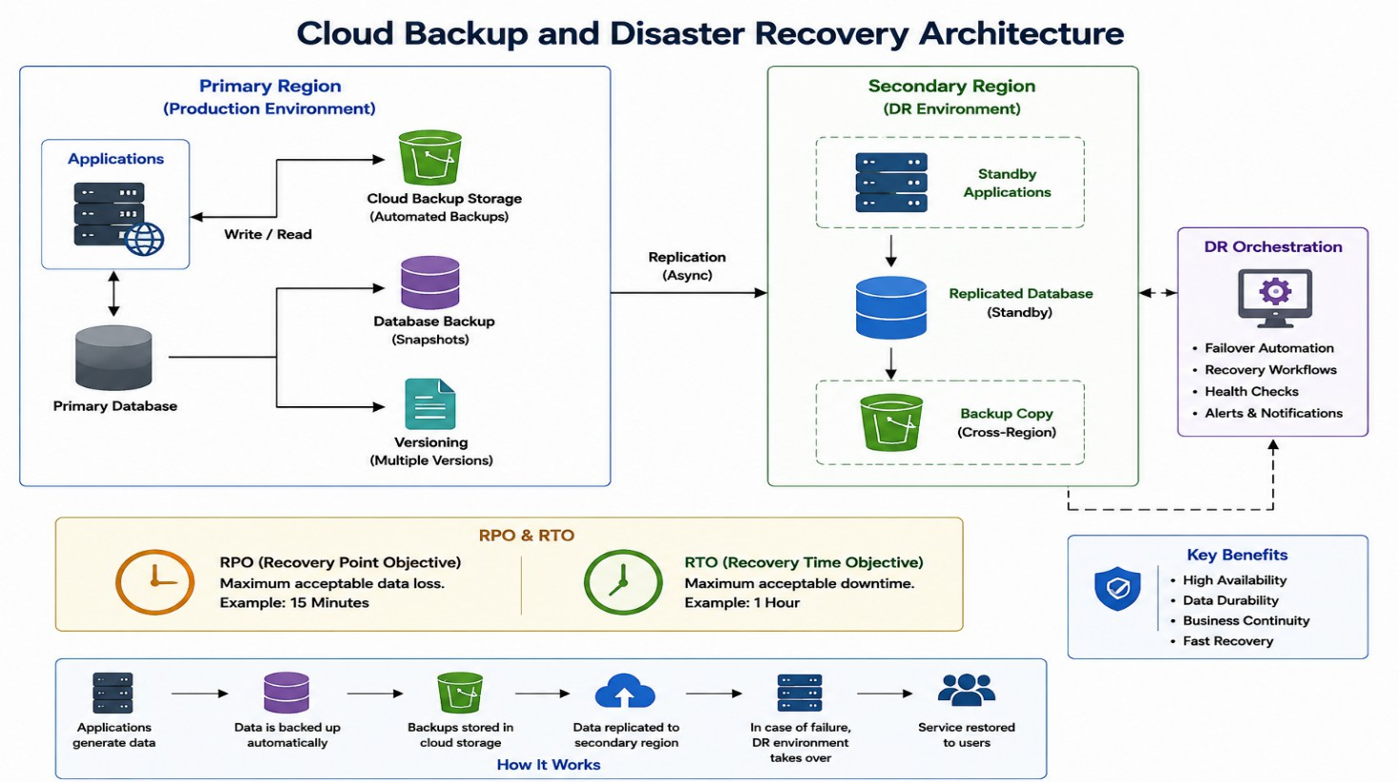
A suitable solution is:
Production Database/Storage
↓ Continuous Replication
↓ Secondary Region
↓
Versioned Backup Storage
↓ Immutable/Protected Backup

Cloud-Native Backup
Important resources should be backed up regularly:
- Student records
- Course information
- Assignment data
- Examination data
- Application configuration
- Databases
- Uploaded documents
Automated backup policies should be used instead of manual backups.

Versioning
Storage versioning keeps older versions of files or objects. For example:

Course.pdf – Version 1 Course.pdf – Version 2 Course.pdf – Version 3
If Version 3 is accidentally deleted or corrupted, an earlier version can be restored.

Replication:
Data should be replicated to another availability zone or region.
Primary Region → Secondary Region
If the primary region fails, services can be restored from the secondary environment.

RPO – Recovery Point Objective
RPO defines how much data loss is acceptable.
Example:
If:
RPO = 15 minutes

The organization should design backups/replication so that a failure does not result in losing more than approximately 15 minutes of data.

RTO – Recovery Time Objective
RTO -defines how quickly the service must be restored. Example:
RTO = 1 hour
The organization should have procedures and infrastructure capable of restoring the application within approximately one hour.

Achieving Low RPO
- Frequent backups
- Continuous database replication
- Transaction logs
- Versioning
- Cross-region replication

Achieving Low RTO
- Automated recovery procedures
- Preconfigured secondary infrastructure
- Automated deployment
- Health monitoring
- DNS/load-balancer failover
- Regular disaster recovery testing

Business Continuity Steps
- Identify critical applications and data.
- Define RTO and RPO.

- Configure automated backups.
- Enable object/file versioning.
- Replicate critical data to another region.
- Protect backups from accidental deletion.
- Create disaster recovery procedures.
- Monitor backup success and replication status.
- Test restoration regularly.
- Document roles and responsibilities during a disaster.

Conclusion
A combination of automated backups, versioning, replication, and disaster recovery automation protects the e-learning platform from accidental deletion and infrastructure failure. RPO determines the acceptable amount of data loss, while RTO determines how quickly services must be recovered.

Hybrid Cloud Architecture for a Government Agency

Scenario
A government agency wants to use a hybrid cloud model. Sensitive information must remain on-premises, while non-sensitive workloads can use the public cloud.

Proposed Hybrid Cloud Architecture:
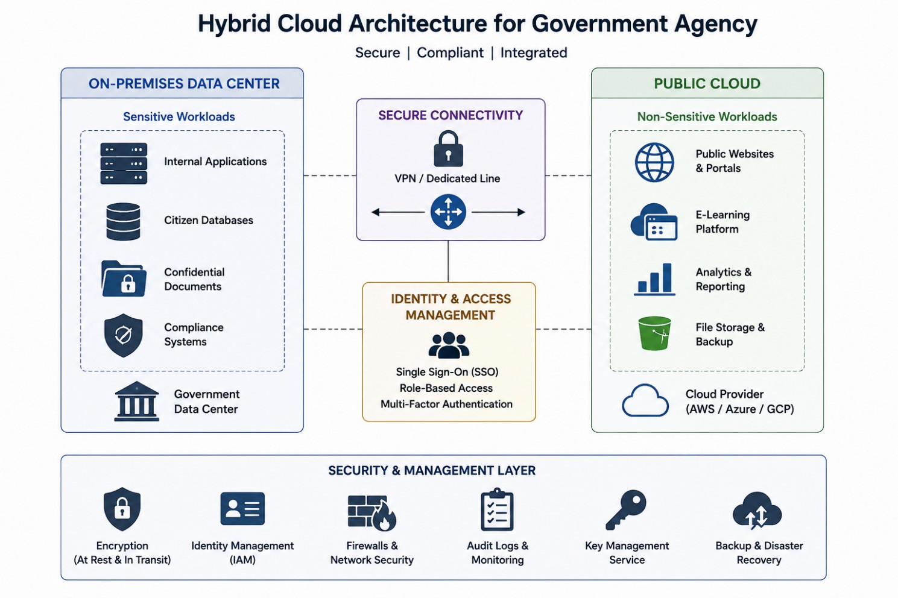

Sensitive Data Non-Sensitive Applications

Examples of sensitive workloads:
    - Citizen records
    - Confidential government documents
    - Internal databases
    - Restricted applications

Examples of cloud workloads:
    - Public websites

    - General information portals
    - Non-sensitive analytics
    - Public content delivery

Secure Communication
The on-premises environment and cloud should communicate through secure connections such as:
    - Site-to-site VPN
    - Dedicated private connectivity
    - Firewalls
    - Network segmentation
    - Private endpoints
Traffic should be controlled using security policies and access-control rules.

Identity Management
A centralized identity management system should be implemented. Important mechanisms include:
    - Single Sign-On
    - Multi-factor authentication
    - Role-Based Access Control
    - Least-privilege permissions
    - Centralized identity management
    - Privileged access management Example:
Administrator → Administrative Resources Employee → Authorized Applications Public User → Public Services
Users should only receive permissions necessary for their responsibilities.

Encryption

Data in transit:
    - Use encrypted communication such as TLS.
    - Use VPN/private encrypted connections between environments.

Data at rest:
    - Encrypt databases.
    - Encrypt cloud storage.
    - Protect encryption keys using a secure key-management service.

Hybrid Cloud Challenges
- Complex network management
- Different security policies
- Identity synchronization
- Compliance requirements
- Data integration problems
- Monitoring across multiple environments
- Higher management complexity
- Different technology platforms

Security Controls
The agency should implement:
  - Firewalls
  - IDS/IPS
  - Encryption
  - MFA
  - IAM
  - Network segmentation
  - Security monitoring
  - Audit logging

  - Regular security assessments
  - Backup and disaster recovery

Conclusion:
Hybrid cloud allows government agencies to keep sensitive workloads on-premises while using cloud infrastructure for appropriate non-sensitive workloads. Secure connectivity, strong IAM, encryption, monitoring, and compliance controls are essential for protecting government data.

Multi-Region High Availability for a SaaS Provider

Scenario
A SaaS provider wants its application to remain available even if an entire cloud region becomes unavailable.

Proposed Multi-Region Architecture:

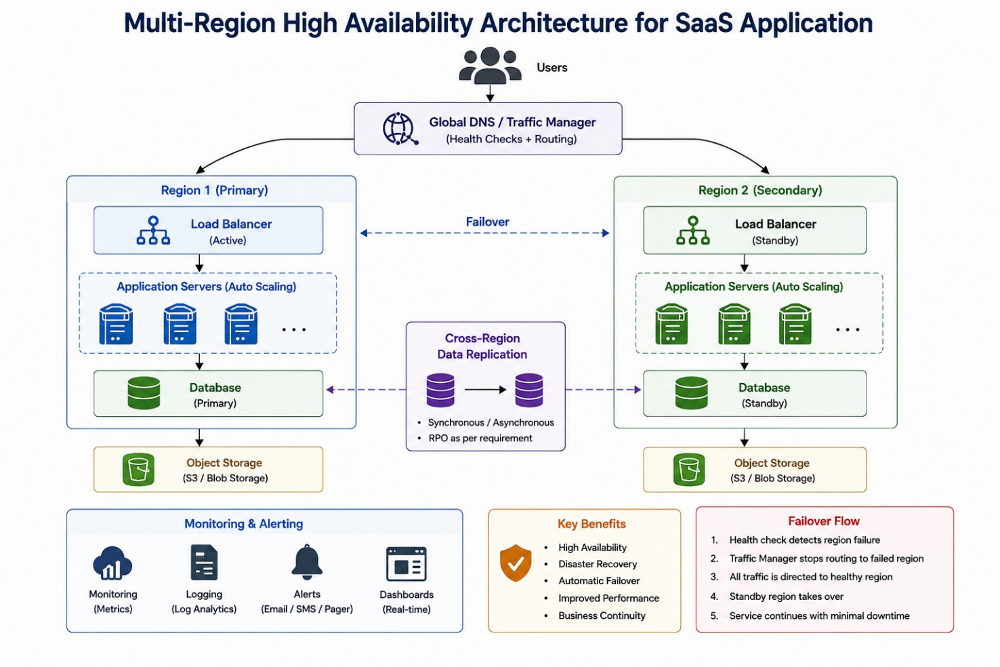

Multi-Region Deployment
Deploy the SaaS application in at least two regions.

For example:
Region A – Primary Region B – Secondary
For higher availability, an active-active architecture can allow both regions to serve users simultaneously.
Alternatively, an active-passive architecture can keep one region ready to take over if the primary region fails.

Data Replication
Data should be replicated between regions. Possible strategies include:
- Synchronous replication where appropriate
- Asynchronous replication for geographically distant regions
- Database replication
- Cross-region object-storage replication
The appropriate strategy depends on consistency, latency, and RPO requirements.

Failover Mechanism
The system continuously monitors application health. Normal operation:
Users → Global Traffic Manager → Region A
If Region A fails:
Users → Global Traffic Manager → Region B
The traffic management layer should automatically redirect users to healthy infrastructure.

Monitoring
The provider should continuously monitor:
- CPU utilization
- Memory usage
- Network traffic
- Application latency
- HTTP error rates
- Database health
- Replication status
- Availability
- Storage capacity
- User requests

Alerting
Alerts should be generated when:
- Application servers become unhealthy
- Error rates increase
- Latency exceeds thresholds
- Database replication fails
- Storage reaches critical levels
- A region becomes unavailable
Alerts can be sent to the operations team through appropriate notification channels.

Proactive Issue Detection
Monitoring should use both metrics and logs. Example:
Latency increases → Monitoring detects abnormal behaviour → Alert generated → Administrator investigates → Traffic redirected if necessary

Automated health checks can detect failures before they become major outages.

Benefits
- High availability
- Reduced downtime
- Regional disaster protection
- Improved user experience
- Better global performance
- Business continuity

Challenges
- Higher infrastructure cost
- Data consistency issues
- Complex database replication
- More complicated monitoring
- Cross-region networking costs
- Increased operational complexity

Conclusion:
A multi-region architecture with replicated data, global traffic management, automated health checks, and failover can keep a SaaS application operational even if one cloud region fails. Continuous monitoring and alerting help detect problems early and support proactive incident management.

